**Quarterly Report – Public Page**

**Date of Report:** 10th Quarterly Report-April 24, 2025

**Contract Number:** 693JK32210003POTA

**Prepared for:** DOT/PHMSA

**Project Title:** Determining the Required Modifications to Safely Repurpose Existing Pipelines to Transport Pure Hydrogen and Hydrogen-Blends

**Prepared by:**  Engineering Mechanics Corporation of Columbus

**Contact Information:**  Gery Wilkowski, (gwilkows@emc-sq.com)

**For quarterly period ending:** March 31, 2025

**DOT/PHMSA TTI:** Louis G. Cardenas

# 1: Items Completed During this Quarterly Period:

The following items were delivered in this quarterly period. The total to be billed for this quarter is $49,500.

|  |  |  |  |  |  |
| --- | --- | --- | --- | --- | --- |
| Item # | Task # | Activity/Deliverable | Title | Federal Cost | Cost Share |
| 47 | 5 | Task 5 – Assess critical flaw sizes and respective detection thresholds | Critical flaw sizes and thresholds assessed | $25,000 | $20,000 |
| 48 | 6 | Task 6 – Review regulatory requirements for safety implications of pipeline conversion | Regulatory requirements for conversion reviewed | $15,000 | $0 |
| 49 | 7 | Task 7 - Determine and describe necessary operator actions | Necessary operator actions determined | $7,000 | $0 |
| 50 | 8 | 10th Quarterly Status Report | Submit 10th quarterly report | $2,500 | $0 |

# 2: Items Not Completed During this Quarterly Period:

We are on target this quarter, although the quarterly report was a few weeks late due to complications in the evaluation of hydrogen and hydrotest on the rupture-free operating time evaluations in Task 5.

# 3: Project Financial Tracking During this Quarterly Period:

The financial tracking bar graph was put on a cumulative rather than a quarterly basis. This graph shows that we are on track.

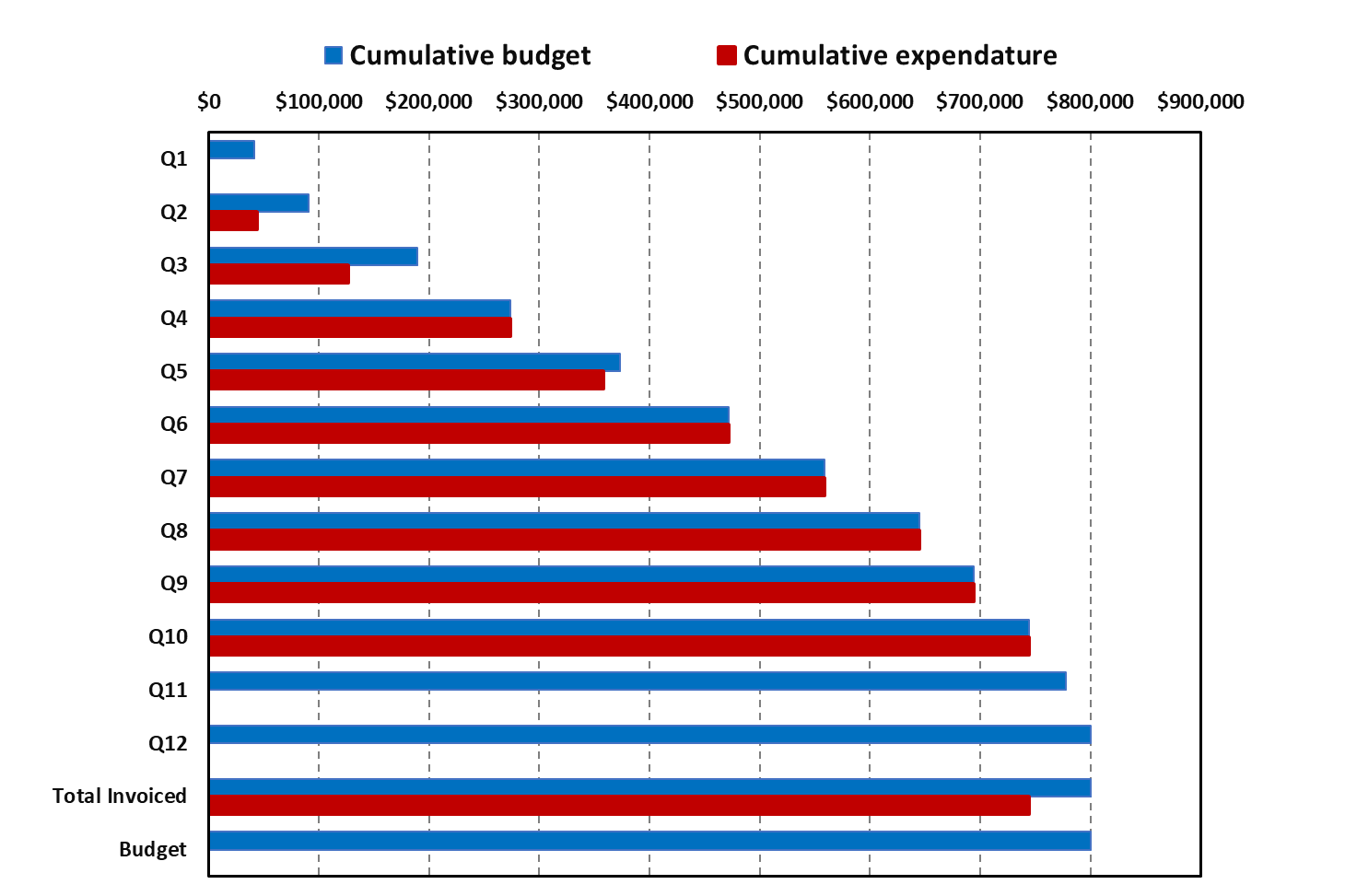

# 4: Project Technical Status

Work continued during the last quarter, as summarized below.

## Task 1 – Literature Review

Completed.

## Task 2 – Identify Potential Limitations in Components and Pipeline Conditions

Completed.

## Task 3 – Evaluate Non-Metallic Components for Retrofit or Replacement

Completed. There is nothing additional to comment on at this time.

## Task 4 – Develop Assessment and Repair Procedures for Identified Anomalies

Completed.

## Task 5 – Assess Critical Flaw Sizes and Respective Detection Thresholds

The evaluations during this time period are reported below on two additional topics.

### 5.1 An Evaluation of the Effect of Hydrotest Pressure Level on Fatigue Life of a Pipeline Case With and Without Blended Hydrogen

This effort used the developments from a parallel ongoing DOT/PHMSA project on "Hydrostatic Test Optimization for Older Liquid Pipelines," DOT/PHMSA Agreement #693JK32010010POTA.

In that project, the potential benefits of a hydrotest causing crack-retardation effects on the fatigue life was evaluated. Crack retardation is typically ignored for pipeline fatigue evaluations from pressure cycling. Liquid lines have more and larger pressure cycles than gas lines. The fatigue crack growth law typically applies to a crack in an inert environment for current pipeline applications. This effort also used the fatigue crack growth rate (FCGR) for hydrogen from the ASME Code Case 2938-2 equations to see how that growth behavior compares to air fatigue crack growth behavior.

A hypothetical case was evaluated: a 16" by 0.267" X46 pipe with an actual yield strength of 53 ksi and a Charpy plateau energy (CVP) of 40 ft-lb typical of a 1960 vintage linepipe. The peak operating stress was taken as 920 psig (60% SMYS) with an assumed pressure cycling R-ratio of 0.6 and 2 cycles per day.

For this evaluation, the number of cycles (or time to failure) was based on a crack size with a length equal to the critical through-wall-crack length at the maximum operating pressure. A shorter crack length would leak first, and the crack growth in the length direction takes many more cycles to reach a rupture condition. Hence, using this crack length gives the minimum rupture-free time or number of cycles. Generally, for fatigue crack growth, the growth in the length direction of a surface crack is very small, so the change in the crack length is minimal when looking at the family of surface cracks that might survive a hydrotest.

In the crack retardation procedure, a large number of SEN(T) tests and some C(T) tests were used to look at the crack retardation effects. The SEN(T) specimens used the base metal of a 1960 vintage pipe. Fracture toughness tests were first done with different a/W values to get the crack initiation toughness (Ji). Ji varies linearly with (1-a/W), see Reference [1], and was similarly found for this material in testing in the companion project. Since the goal was to optimize the level of the hydrotest and there were a number of different surface cracks that survived the hydrotest, the overload in the specimen tests was characterized as the ratio of the applied J (Japp) to the initiation toughness (Japp/Ji). The Japp values could also be calculated for the surface-cracked pipe, and the constraint condition of the surface crack in the pipe is similar to that of a SEN(T) specimen.

For the SEN(T) test data, the Ji was calculated by the CANMET eta-factor solution, which is the best available solution from Emc2 reviews. For the axial surface-cracked pipe fracture mechanics solution, the companion DOT/PHMSA project spent considerable time investigating analyses that gave an accurate solution of the applied J, Japp. It was found necessary to develop a new J-estimation scheme [2] by a more careful fitting of FE results than was done by the MAT-8 approach [3]. A graphical display of the crucial surface and through-wall-cracked pipe burst pressures for this case is given in Figure 1. Note that the surface-crack curves blend into the uncracked pipe burst pressure, and if a/t>0.15, the pipe fails by the burst pressure.

The horizontal dotted lines are the peak operating pressure and several hydrotest pressure levels. The black dashed curve is the though-wall-cracked (TWC) pipe failure curve using the Maxey/Kiefner Ln-Sec solution [4]. At the peak operating pressure, the critical total though-wall-crack length is 5.94 inches, and the critical surface-crack depth (assuming a constant depth crack, not semi-elliptical) is an a/t=0.58. The LnSec TWC curve is based on flow stress, so it doesn't blend into the unflawed pipe burst pressure, which is more a function of the pipe's ultimate strength. The TWC curve should go to the unflawed curve as the TWC length goes to zero, but this is the most used analysis procedure.

The critical surface cracks for each hydrotest pressure level are for this length. Where the pressure curves cross an a/t curve (or interpolation of those curves), give the critical surface-crack a/t values for each hydrotest pressure level, which is found along the vertical red arrow. Surface cracks with shallower a/t values will survive those hydrotests.

Figure Calculated burst pressure for axial through-wall cracks and axial surface cracks using the Emc2 FE-based J-estimation scheme [2] with pressure levels at peak operating pressure and various hydrotest levels

In the SEN(T) cyclic testing, the various specimens were loaded to Japp/Ji values of 0.1, 0.5, and 1.0 for different levels of hydrotest simulation. Then, the specimens were fatigue cycled at two different cyclic stress levels values but at smaller maximum load levels than the overload simulating the hydrotest.

For the approach to be pragmatically applicable for the hundreds of cases to be run, the crack retardation approach used was relatively simple, so bounding results were used. The retardation effect is the ratio of the total fatigue life after the overload divided by the total fatigue without the overload as a function of Japp/Ji. (An experimental difficulty is that both specimens must have identical starting crack lengths.) Factors like the applied cyclic stress level and different initial a/t values in the SEN(T) tests were examined but were found to be reasonably accounted for by the normalization procedure used. It is well recognized that doing this type of fatigue retardation modeling is not as theoretically pleasing since, in reality, the overload retards the start of the crack growth for a considerable number of cycles. However, for the purposes of this analysis, only the crack growth at the end-of-life (leakage or rupture) is of interest, not the crack growth at some number of cycles into the loading history. An additional limitation of this approach to the work was that the SEN(T) specimens with a width equal to the same thickness of the pipe were used to get the retardation values. When looking at the cyclic C(T) test data, this crack retardation definition gave much lower values, which came from the fact that the ligament in the C(T) specimen (amount of fatigue crack growth to failure) was much greater than the ligament than in the SEN(T) specimens having a width equal to the pipe thickness. The resulting bounding Fatigue Life Extension Ratio (FLER) is given in Equation (1) and is shown in Figure 2 with the test results. Many run-out cases were above this curve, where the number of cycles exceeded 1 million.

FLER= 0.000331(Japp/Ji)2 + 0.050495(Japp/Ji) + 1.0000 (1)

1. With just SENT data (b) With SC Pipe data that had small ductile tear

Figure Fatigue Life Extension Ratio (FLER) fitting using SEN(T) and surface-cracked pipe test data

For the fatigue life analyses, the value of (1/FLER) is multiplied by the constant in the FCGR equation, i.e.,

da/dn = (C/FLER)DKm (2)

For the hydrotest evaluations, hydrotest values from 1.1 to 2 times the maximum operating pressure were used. For each of these hydrotest cases, the surface-crack length was made equal to that of the leak-rupture through-wall-crack length at the maximum operating pressure. The critical a/t values for the surface cracks at each hydrotest pressure level were calculated using the FE-based J-estimation scheme as illustrated in Figure 1, but also including the relationship between Ji and a/w for the fracture toughness that could be determined from the user input of the material's Charpy upper-shelf energy per Equation (2) below.

Ji-SEN(T) = 30CVP(0.9-a/t) (3)

The user also needed to input only the SMYS of the pipe, and they could add a factor for the actual yield strength/SMYS if desired. The ultimate strength was calculated from API 5L requirements by grade. Then, the strain-hardening exponent (needed for the Ramberg-Osgood curve in the surface-cracked-pipe J-estimation scheme) was determined from a relationship developed with Southern California Gas data [5] that was a function of the Y/U ratio.

Knowing that the surface-crack lengths for the aspect ratios of interest have insignificant crack growth in the length direction, then for each hydrotest pressure level, the surface-crack depths of the surviving cracks were determined (again see Figure 1), and the applied J values (Japp) for the crack retardation of the surviving surface cracks were calculated, see Figure 3.

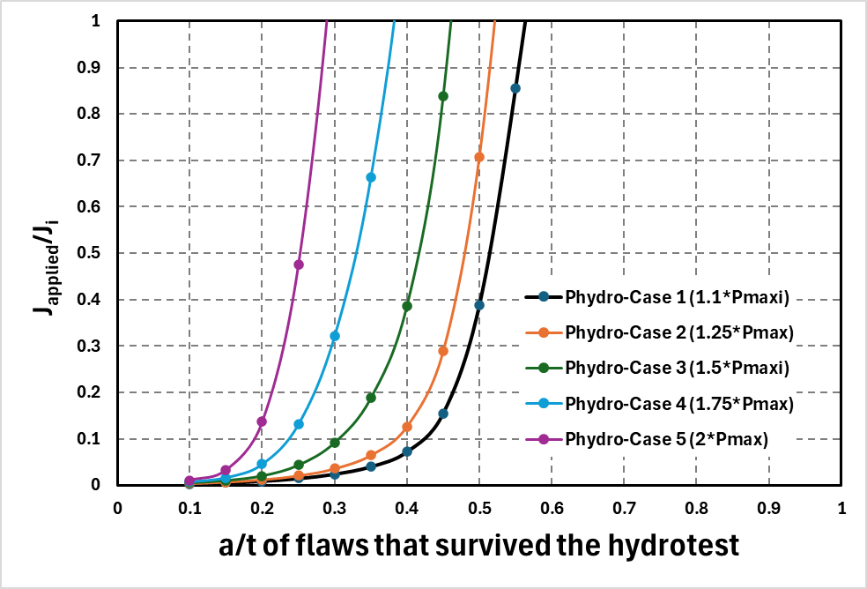

Figure Calculated Japp/Ji values for various surviving surface cracks

The fatigue crack growth equations used were the air environment curve from API-579 for lower-strength ferritic steels and the hydrogen-gas curve from ASME Code Case 2938-2. The hydrogen gas curve has lower and upper curve contributions, and the cross-over point needs to be solved so that the automated analyses properly follow the log-bilinear trend. The lower region is sensitive to the partial pressure of the hydrogen gas blend, while the upper part is not sensitive to the hydrogen gas partial pressure. For this example, in the case of only a 10% blend of hydrogen in the gas, the cross-over point is higher than if 100% hydrogen was used; see Figure 4.

Figure Air (from API 579) and hydrogen gas (from ASME Code Case 2938-2) fatigue crack growth equations used

The number of cycles for the different surface-crack-depth cases to reach the critical-surface-crack depth at the maximum operating pressure was then calculated. This calculation was done with and without crack retardation, as well as with air and hydrogen FCGR curves. Using increments of a/t of 0.05 starting from a/t=0.1 to the depth of the surviving surface crack at the hydrotest of interest was found to be adequate (although the spreadsheet tables are still quite large). Every surviving surface crack with a different a/t has a different FLEX value, i.e., shallow surface cracks have low Japp/Ji and FLER values. In contrast, cracks that just survive the hydrotest will have large Japp/Ji values and hence a larger amount of crack retardation. An example comparison of the difference of the minimum number of rupture-free cycles versus the a/t of the surviving flaws is shown in Figure 5. With the crack retardation analysis, it can be seen that the number of rupture-free cycles has a minimum a/t value that is larger than the largest depth flaw that survived the hydrotest. This is because the FLER values increase significantly for a/t values greater than this depth.

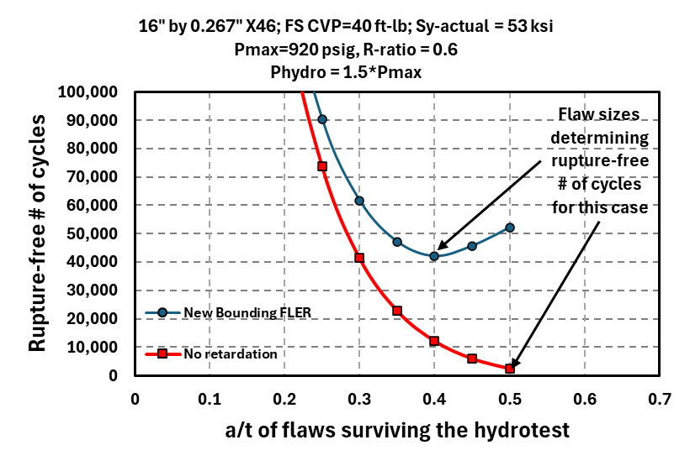

Figure Example case showing minimum number of cycles for surface cracks that survived a hydrotest of 1.5*Pmax with and without crack retardation, and the air fatigue crack growth relationship

The results of the analyses for determining the minimum rupture-free time after a hydrotest with and without crack closure with air and blended hydrogen gas environments are shown in Figure 6. The hydrotest cases run were for 1.1, 1.25, 1.5, and 2 times the maximum operating pressure, although a factor of 1.66 corresponded to a hydrotest of 100% SMYS. Running a few additional hydrotest pressure levels would make the curve fit slightly better, but these cases were sufficient to show the trends of interest.

These cases had the trends of the air environment having significantly better fatigue life, and also, the crack retardation effect improves the life considerably. (It should be noted that in other cases with much lower operating pressure more typical of a vintage liquid line, the best air/crack retardation curve is not as high as this case.)

The trend with 10% hydrogen for this case does not have much benefit of the hydrotest until the hydrotest pressure exceeds a factor of 1.5, but there is a rapid life improvement with hydrotest pressure levels above 1.5. The implication is that with a hydrotest pressure of ~1.57, then the 10% blend hydrogen fatigue life would increase to 10 years, and 20-year life could be obtained with the hydrotest pressure of 1.64, both with the crack retardation. *This evaluation suggests that the hydrotest aspects are potentially high-value and worth additional evaluation/refinement.*

The following refinements are still needed but are outside the current project workscope.

1. The fracture toughness was assumed to be the same in the air and 10% blend hydrogen cases. This can be easily programmed into the Hydrotest Optimization Procedure analysis for fatigue crack growth (HOP-F). There will be some toughness reduction with the hydrogen, although the magnitude of that reduction is still a highly debatable aspect; see discussions in the 9th quarterly report from this project in Task 5.
   1. There is an EPRG hydrogen autoclave testing round-robin that will also include data-reduction procedures and help assess the large differences in hydrogen toughness from different data reduction processes. That effort will not be completed until the end of this project (~fall 2025), although a few sensitivity studies could be conducted.
   2. Additionally, there are some full-scale pipe tests from the past and recent/ongoing ones to validate fracture toughness with hydrogen results.
2. Some full-scale fatigue pipe tests with hydrogen gas are being conducted, which can be useful in assessing the Code Case 2938-2 fatigue crack growth equations to a surface-cracked pipe.
3. The Fatigue Life Extension Ratio (FLER) for the crack retardation was assumed to be the same with air and hydrogen environments. We currently know of no planned tests to assess this assumption since these hydrotest evaluation results for hydrogen gas have been presented here for the first time. It would be possible to conduct a few SEN(T) tests in a hydrogen autoclave to assess if the air environment FLEX equation upholds in hydrogen prior to determining if any full-scale pipe tests are warranted.
   1. From the hydrogen concentration numerical evaluations done within this project (see prior quarterly reports), we have found that after a hydrotest, there is an increase in plastic strain with compressive stresses. Hydrogen concentrations will increase with plastic strain, and the plastic strain is more important than interstitial trapping sites from trapping at hydrostatic stresses interstitial sites. So after the hydrotest and return to the maximum operating pressure, more hydrogen could be trapped at the crack than if the hydrotest was not conducted, see Figure 7. However, if the crack-tip region has compressive stresses after the hydrotest, then even with the higher hydrogen concentration, there is still retardation of the crack growth.

Figure Example case showing the minimum rupture-free life with an inert environment versus 10% blended hydrogen environmental effects on FCGR with and without crack retardation

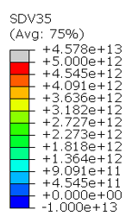 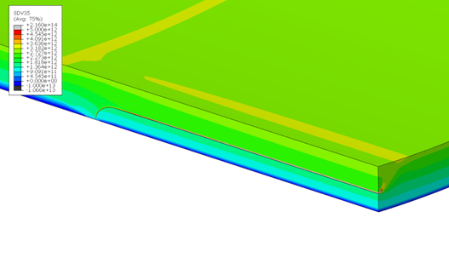

1. Hydrogen concentration at MAOP b) Hydrogen concentration after 1.5 hydrotest at MAOP

**Figure 7 Hydrogen trapping FE analysis at 60% SMYS with axial surface crack without (a) or with a prior hydrotest (b)**

Note, scale in number of trapped atoms per cubic mm

### 5.2 Modeling Notched Bars to Explore Triaxiality Effects on Damage Evolution

The effects of hydrogen on pipeline steels have been evaluated experimentally to obtain properties such as fracture toughness, tensile fracture strain, and fatigue crack growth rate. These effects have been discussed in the literature review for this project, as well as the findings of a previous effort conducted by Emc2 for PHMSA, [6], [7] At this point, efforts are underway to assess how to make reasonable fracture mechanics analyses for crack-like flaws and estimate remaining life under cyclic operation, see prior discussion. However, the impact of hydrogen on other forms of damage is far less certain. For various forms of deformation, such as dents, gouges, wrinkle bends, pipe displacement due to ground movement, or locally corroded areas, where failure pressure is dictated by plastic collapse, there is a lack of full-scale test data to validate models. The only inferences that can be made are related to the apparent loss in fracture ductility in tensile tests of steels run in gaseous hydrogen or charged electrolytically. The data show that there is little effect on the yield strength and ultimate tensile strength but a drop in the elongation or reduction in area. The magnitude of the effect is also rate-dependent, presumably due to the time it takes for hydrogen to diffuse the regions of higher stress-strain. This effect is illustrated in Figure 8, showing data from Wang et al. [8].



Figure Loss in ductility of X65 when charged with hydrogen

Due to this loss in ductility, it may be inferred that the minimum pressure required for plastic collapse is lower. This loss in ductility has been studied by Depraetere et al. [9], who examined the effects of stress state on the ductile damage of pipeline steels.

While the detrimental effects of hydrogen on ductility have been well established in tensile testing, the magnitude of this effect remains an open question when applied to the evaluation of the plastic collapse limit for pipelines with various forms of damage. Ultimately, experimental work involving full-scale testing will need to be conducted to explore this; however, information may be gleaned through small-scale test work coupled with modeling efforts. Current models, like B31G or RSTRENG, estimate the burst pressure of local corrosion using flow stress, which is correlated to test data. Unfortunately, as the yield and ultimate tensile strength are not strongly affected by the presence of hydrogen, it is impossible to use these models directly to incorporate the effects of hydrogen. Therefore, in this project, the criticality of deformation-related damage, referred to hereafter as volumetric damage, is being explored using a finite element analysis utilizing the phase field (PF) approach. This methodology enables damage to be modeled and related to the load capacity of a structure. This is analogous to using a fracture-mechanics analysis of a crack-like flaw where the presence of hydrogen degrades the fracture toughness, thereby reducing the critical stress for unstable fracture. In the case of volumetric damage, however, hydrogen concentration is correlated to damage. Here, damage can be characterized as the ratio of accumulated strain to fracture strain $\frac{ε_{total}}{ε_{fracture}}$. In the context of PF analysis, damage becomes a function of the equivalent stress, damage, and plastic strain, $f(σ_{e},d,{\overline{ε}}^{p})$. To explore the damage development associated with localized regions of damage in a pipeline, it is first necessary to solve the hydrogen transport due to the local hydrostatic tensile stress and the plastic strain. The dilation of the crystal lattice, resulting from the hydrostatic stress field, provides a driving force for hydrogen diffusion, while plastic strain creates trap sites, increasing hydrogen solubility. Once the spatial distribution of hydrogen concentration is known, the next step is to relate this to the damage parameter. Huang and Gao have developed a framework for accomplishing this that effectively reduces the yield surface locally (near the region of stress concentration) as a function of hydrogen concentration. This, in turn, degrades the load-bearing capacity for both local and global collapse.

The approach being taken here is to evaluate notched bars with various acuities and examine the damage evolution and collapse limit using PF analysis. Three different geometries are being considered:

* Smooth bar,
* Circular notch (Bridgman notch), ρ = 3.0 mm, and
* Sharp Vee-type notch with a small radius, ρ = 0.2mm.

Figure Possible specimen geometries for suggested Phase Field (PF) future evaluation

Notch bars are chosen as they provide a range of stress triaxialities, just like various damage geometries. While the range of triaxiality $\left(\frac{σ_{H}}{σ_{e}}\right)$ that can be achieved in notched bars is somewhat limited. Historically, this type of specimen geometry has been convenient and economical to test experimentally. Therefore, the predictions from the analysis can be tested in future work.

The initial boundary conditions will have the test specimen immersed in hydrogen, with the surface concentration estimated by Sievert's Law. The load is applied in pure tension at a strain rate (displacement rate) sufficiently slow to permit the stress and strain fields to affect the hydrogen concentration through the specimen in the same manner as would be the case for pipeline damage. Following the approach of Drexler et al., a modified Sievert's Law is used to account for the increased stress and the surface, which will produce an initially high hydrogen concentration at the throat of the notch, i.e., the location of maximum principal stress, σ1. As loading increases, yielding will eventually occur, and stress redistribution will occur. This change in stress will affect the hydrogen concentration through the specimen and, therefore, the damage evolution and the resulting load-displacement curve. The variation in behavior is expected to provide some insight into the effects of stress triaxiality on failure load. As mentioned earlier, it is expected that higher triaxiality will result in a reduction in the load-displacement curve due to two factors. The first is the effect of constraint on fracture strain, which will take place irrespective of the presence of hydrogen. The constraint effect is a well-characterized phenomenon, and various models exist to consider this. The second factor, and the one of primary interest here, is the damage evolution caused by hydrogen and its impact on the load-displacement curve. By comparing the magnitude of the effects of stress triaxiality on fracture strain, it is hoped that some indication will be given regarding the likely effect that hydrogen may have on the criticality of volumetric defects.

## Task 6 – Review Regulatory Requirements for Safety Implications of Pipeline Conversion

The last quarterly report included a thorough review of the regulatory requirements and safety implications. The B31.8 hydrogen task group is voting on a draft supplement for new and repurposed hydrogen pipelines, the final review aspect planned for this project.

## Task 7 – Determine and Describe Necessary Operator Actions

These aspects were addressed in detail in the last quarterly report. There may be some minor updates for this activity for the draft final report, which may come from the B31.8 hydrogen draft procedure document and any publications in the interim, i.e., PRCI REX meeting and the PRCI JTM conference.

## Task 8 – Deliver Reported Results

### Subtask 8a Deliver Reported Results - Quarterly reports

The quarterly reports have been delivered routinely. This report took longer due to the challenges in doing the hydrotest evaluations with hydrogen fatigue crack growth, which we initially thought might be a relatively straightforward extension of efforts from a companion DOT/PHMSA project. The changes were not that simple and took considerable QA.

### Subtask 8b Deliver Reported Results - Draft Final Report

The outline of the draft-final report is completed, and some writing of the inputs has already started.

### Subtask 8c Deliver Reported Results – Deliver Review Comments from Academic Advisors

This activity will not start until the draft-final report is completed. We have academic advisors lined up to assist in this review.

### Subtask 8d Deliver Reported Results - Deliver Updated Final Report

This activity has not started yet. It will be done after the academic advisor review comments are received and included in the draft final report.

## Task 9 – Technology Transfer

### Subtask 9a Technology Transfer - Presentation of Results

After the final report version from Subtask 8d is completed, DOT/PHMSA staff will organize a Project Debrief presentation to PHMSA/DOT staff as well as industry.

### Subtask 9b Technology Transfer - Publication

Some of this project's results were presented at the 2024 IPC conference. Abstracts will be submitted for the 2026 IPC conference, but that will not happen until the call for abstracts next fall.

### Subtask 9c Deliver Public Version of Final Report

The last version of the final report will include any suggestions or comments for the project debrief meeting in Subtask 9a.

# 5: Project Schedule

The GANTT chart for the project below was updated from the prior quarterly report. The efforts are on schedule.



**References**

|  |  |
| --- | --- |
| [1] | G. Wilkowski, S. Kalyanam, Y. Hioe, F. Brust, S. Pothana, M. Uddin and F. Orth, "Constraint Effects of Surface Crack Depth on Toughness – Experimental and Numerical Assessments," in *Proceedings of the ASME 2019 Pressure Vessels & Piping Conference*, 2019. |
| [2] | G. Wilkowski, J. K. Hong, F. W. Brust and Y. Hioe, "An Improved Axial Surface Crack Model to Predict Crack Growth and Burst Pressures Based on FE Analyses for Jplastic and J-R Curve Methodology," in *IPC2022- 86904*, September 26-30, 2022. |
| [3] | T. Anderson, "Development of a Modern Assessment Method for Longitudinal Seam Weld Cracks, Catalog No. PR-460-134506-R01," Pipeline Research Council Inc., 2015. |
| [4] | J. F. Kiefner, "Fracture Initiation," in *Symposium in Line Pipe Research, Pipeline Research Committee of American Gas Association, Section G*, Dallas, TX, November 1969. |
| [5] | E. Brady, J. Kornuta, J. Anderson, A. Steiner and a. P. Veloo, "Improvements to Strain Hardening Exponent and the Implications to Failure Pressure Predictions," in *IPC 2022 - Paper #86041*, Alberta, 2022. |
| [6] | K. Bagnoli, L. Hill and G. Wilkowski, "Review of Integrity Threat Characterization Resulting from Hydrogen Gas Pipeline Service," Pipeline Hazardous Materials Safety Administration, Washington, D.C., 2023. |
| [7] | K. Bagnoli, L. Hill and G. Wilkowski, "Literature Survey on Repurposing Pipelines for Hydrogen Service," DOT/PHMSA, Washington, DC, 2023. |
| [8] | D. Wang, A. Hagen, P. Fathi, M. Lin, R. Johnson and X. Lu, "Investigation of Hydrogen Embrittlement Behavior in X65 Pipeline Steel Under Different Charging Conditions," *Materials Science & Engineering A,* vol. 860, 2022. |
| [9] | R. Depraetere, W. De Waele, M. Cauwels, T. Depover, K. Verbeken and S. Hertele, "Single Edge Notch Tension Testing for Assessing Hydrogen Embrittlement: A Numerical Study of Test Parameter Influences," in *8th European Congress on the Computational Methods in Applied Science and Engineering*, Oslo, 2022. |